

INVENTION DISCLOSURE FORM

Ques.1. Title of your invention
Neuro Calm Smart Spectacles: AI-Based Migraine Detection and Trigeminal Neuromodulation Eyewear

Ques.2. Type of Invention
- Biomedical Wearable Device
- Smart Healthcare Technology
- Neuromodulation-Based Migraine Relief System
- AI Integrated Medical Eyewear.

Ques.3. Brief Description of your invention

The present invention relates to a wearable smart spectacle device named “NeuroCalm Smart Spectacles” designed for the early detection, monitoring, and management of migraine attacks. The device is developed in the form of normal eyeglasses to provide comfort, portability, and continuous daily use. It integrates advanced biosensors such as photoplethysmography (PPG) sensors, temperature sensors, and stress monitoring sensors to detect physiological changes associated with migraine onset, including vasodilation, increased temperature, and trigeminal nerve activation around the forehead and temple region.

The device contains miniature vibration motors and cooling modules embedded within the spectacle frame. When abnormal migraine-related signals are detected, the system automatically activates vibration therapy and cooling therapy to reduce pain perception, inflammation, and nerve sensitivity. Optional low-intensity trigeminal nerve stimulation can also be incorporated for enhanced neuromodulation therapy.

The smart spectacles are powered by a rechargeable battery and controlled through a microcontroller with Bluetooth connectivity for mobile application support and health monitoring. This invention provides a non-invasive, drug-free, lightweight, and user-friendly solution for migraine prevention and relief while improving patient comfort, mobility, and quality of life.

Ques.4. Objective of your invention

The primary objective of the present invention is to develop a smart wearable spectacle device for the early detection, monitoring, and non-invasive treatment of migraine attacks. The invention aims to provide a drug-free and portable solution that can continuously monitor physiological changes associated with migraine onset, such as vasodilation, temperature fluctuation, and trigeminal nerve activation.

Another objective of the invention is to integrate biosensors, vibration therapy, cooling therapy, and optional trigeminal nerve stimulation into a compact spectacle design that resembles normal eyeglasses for comfortable daily use. The device is intended to provide immediate therapeutic intervention during the initial stages of migraine in order to reduce pain intensity, inflammation, and migraine progression.

The invention also aims to improve patient convenience and quality of life by reducing dependence on medications and minimizing side effects associated with conventional migraine treatments. Additionally, the system seeks to incorporate AI-assisted monitoring and predictive analysis for identifying migraine patterns and triggering automated therapy.

Overall, the objective of the invention is to create an intelligent, wearable, lightweight, and user-friendly healthcare device capable of preventive and real-time migraine management.

Ques.5. How to use the invention

The invention is designed in the form of smart spectacles and can be used similarly to regular eyeglasses. The user wears the device comfortably over the eyes and forehead region during daily activities or whenever migraine symptoms are expected. Once powered on, the integrated biosensors continuously monitor physiological parameters such as blood flow, temperature variation, and stress-related changes around the temple and forehead area that are associated with migraine onset.When the system detects abnormal migraine-related signals such as vasodilation or increased nerve activity, the device automatically activates therapeutic functions including gentle vibration therapy and localized cooling therapy to reduce pain perception and inflammation. The user can also manually activate or adjust therapy modes through a control button present on the spectacle frame or through a connected mobile application using Bluetooth connectivity.The device operates on a rechargeable battery and can be charged using a USB Type-C charging port. The lightweight and wearable design allows the user to use the device comfortably at home, workplace, during travel, or in daily routine activities. Regular use of the invention may help in early migraine management, pain reduction, and prevention of severe migraine attacks.

Ques.6. Problem your invention is solving

Migraine is a highly prevalent neurological disorder that affects millions of people worldwide and significantly impacts daily life, productivity, mental health, and overall well-being. Individuals suffering from migraines commonly experience severe headache, throbbing pain, nausea, dizziness, light sensitivity, sound sensitivity, and difficulty concentrating. In many cases, migraine attacks occur suddenly and interfere with work, education, sleep, and social activities. Existing treatment methods mainly depend on oral medications, injections, or painkillers, which often provide delayed relief and may cause side effects such as drowsiness, gastric irritation, medication dependency, and reduced long-term effectiveness.

Another major problem in migraine management is the lack of early detection systems capable of identifying physiological changes before the severe pain phase begins. Migraine attacks are associated with vasodilation, trigeminal nerve activation, stress-related changes, and inflammatory responses, but currently available treatments usually start only after the pain becomes intense.

This delay reduces treatment effectiveness and increases patient discomfort. Existing neuromodulation devices for migraine relief are often bulky, uncomfortable, expensive, or designed as separate forehead patches and external stimulators, making them inconvenient for continuous daily use. Most wearable healthcare devices also lack integration of both monitoring and therapeutic functions in a single compact system.

The present invention addresses these limitations by providing a lightweight smart spectacle device capable of continuously monitoring migraine-related physiological changes and automatically delivering non-invasive therapeutic intervention through vibration therapy, cooling therapy, and optional trigeminal nerve stimulation.

The invention offers a drug-free, portable, and user-friendly solution for both migraine prediction and management.

It helps reduce dependence on medications, improves comfort during migraine attacks, and enables preventive healthcare through early detection and immediate response therapy in a normal spectacle-like wearable design.
Ques.7. Purpose and object of Invention

The purpose of the present invention is to develop an advanced smart wearable spectacle device capable of detecting, monitoring, and managing migraine attacks through a non-invasive and drug-free therapeutic approach. The invention is designed to provide a practical, portable, and comfortable healthcare solution that can be used continuously in daily life without causing inconvenience to the user. By integrating biosensing technology and neuromodulation therapy into a spectacle-like wearable design, the invention aims to improve migraine management and patient quality of life.

One of the primary objects of the invention is to identify early physiological changes associated with migraine onset, such as vasodilation, temperature changes, stress fluctuations, and trigeminal nerve activation. Early detection allows immediate therapeutic intervention before the migraine reaches a severe stage. The invention therefore aims to reduce the frequency, intensity, and duration of migraine attacks through continuous monitoring and automated response mechanisms.

Another important object of the invention is to provide localized therapy using vibration stimulation, cooling therapy, and optional transcutaneous electrical nerve stimulation around the trigeminal nerve region. These therapies are intended to reduce pain transmission, inflammation, vascular dilation, and nerve hypersensitivity associated with migraine attacks.

The invention also aims to minimize dependence on pharmaceutical drugs and reduce side effects caused by long-term use of painkillers and migraine medications. Additionally, the device is intended to function as a smart healthcare platform capable of integrating Bluetooth communication, mobile application support, and AI-assisted migraine pattern analysis for personalized healthcare monitoring.

Overall, the invention seeks to create an intelligent, wearable, safe, lightweight, and user-friendly migraine management system that combines preventive monitoring and therapeutic intervention within a normal spectacle framework suitable for routine everyday use.

Ques.8. Discuss potential commercial application of the invention.

The present invention has significant commercial potential in the fields of healthcare technology, wearable medical devices, neurology, and smart wellness products. Migraine is one of the most common neurological disorders affecting a large global population, creating a strong market demand for portable, non-invasive, and drug-free migraine management solutions. The proposed smart spectacle device can be commercially developed as an advanced wearable healthcare product for individuals suffering from chronic or recurrent migraines.

One of the major commercial applications of the invention is in the medical and neurological healthcare sector, where the device can be recommended by neurologists, migraine specialists, pain management clinics, and hospitals as a supportive therapy for migraine prevention and relief. The invention can also be marketed in the consumer wellness and smart wearable industry as a daily-use health monitoring device similar to smartwatches and fitness trackers.

The device has potential applications in corporate wellness programs, educational institutions, and workplaces where stress-induced migraines are common. Integration with mobile applications and AI-based migraine monitoring systems can further support personalized healthcare services and subscription-based digital health platforms.

The invention may also attract partnerships with biomedical companies, wearable electronics manufacturers, and pharmaceutical industries interested in developing combination therapy systems for neurological disorders. Its lightweight spectacle-like design increases user acceptance and makes it suitable for long-term daily use compared to bulky conventional migraine devices.

Commercially, the product can be launched in multiple versions such as:
- basic vibration therapy spectacles,
- AI-enabled smart monitoring spectacles,
- premium neuromodulation models with app integration.
Overall, the invention possesses strong market value due to its innovative design, portability, preventive healthcare capability, and increasing demand for smart wearable medical technologies in modern healthcare systems.

Ques.9. Provide any additional material (such as photographs, reports, publications, and references to texts or other information material) which may be helpful to an understanding of the invention. Identify and indicate the specific relevance of each.
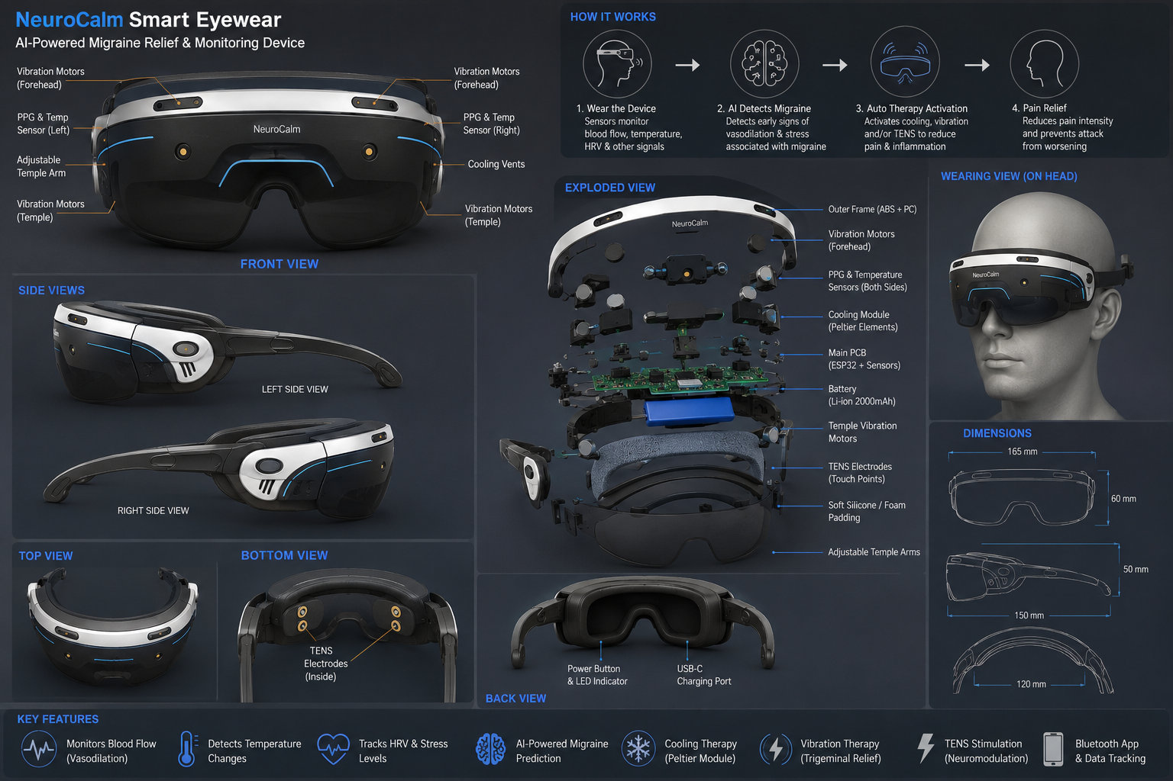

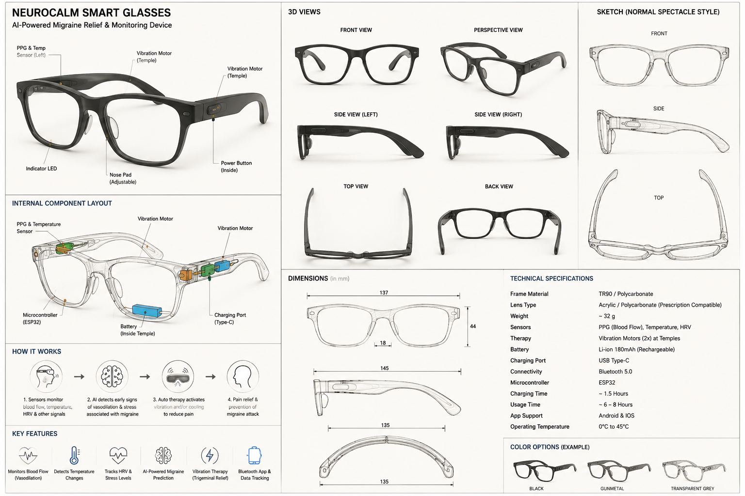

1. Cefaly Dual

A wearable forehead neuromodulation device used for migraine prevention and treatment through external trigeminal nerve stimulation (e-TNS).

Relevance: Supports the concept of trigeminal nerve stimulation used in the present invention.

2. Nerivio

A wearable neuromodulation device that uses electrical stimulation for migraine management.

Relevance: Demonstrates the effectiveness of non-invasive neuromodulation for migraine relief.

3. gammaCore Sapphire

FDA-cleared wearable device used for migraine and cluster headache treatment via vagus nerve stimulation.

Relevance: Supports wearable neuromodulation technology for neurological disorders.

4. Yuan H, Orr SL, Al-Karagholi MA, Ashina M, Cohen F, Diener HC, Dodick DW, Jensen RH, Marmura MJ, Martinelli D, Matharu MS. International Headache Society evidence-based guidelines on the use of non-invasive neuromodulation devices for the acute and preventive treatment of migraine. Cephalalgia. 2026 Oct;45(10):03331024251388377.

Ques.10. Abstract

The present invention relates to a smart wearable spectacle device designed for the early detection, monitoring, and non-invasive treatment of migraine attacks. The invention integrates advanced biosensors and neuromodulation technologies into a lightweight spectacle framework that can be comfortably worn like normal eyeglasses during daily activities. The device continuously monitors physiological parameters associated with migraine onset, including blood flow changes, vasodilation, temperature variation, stress fluctuations, and trigeminal nerve activity around the forehead and temple region.

The invention utilizes integrated photoplethysmography (PPG) sensors, temperature sensors, and stress-monitoring systems to identify abnormal migraine-related patterns. Upon detection of migraine-associated signals, the device automatically activates therapeutic mechanisms such as vibration therapy, localized cooling therapy, and optional transcutaneous electrical nerve stimulation to reduce pain perception, inflammation, vascular dilation, and nerve hypersensitivity.

The smart spectacles are powered by a rechargeable battery and controlled using a microcontroller with optional Bluetooth connectivity and mobile application integration for personalized monitoring and control. The wearable design enables continuous use in home, workplace, travel, and daily environments without discomfort.

The invention provides a drug-free, portable, intelligent, and user-friendly migraine management solution that combines real-time physiological monitoring with automated therapeutic intervention. The proposed system aims to reduce migraine severity, improve patient comfort, minimize dependence on medications, and enhance quality of life through preventive and responsive healthcare technology.

Ques.11. Summary of the invention

The present invention relates to a smart wearable spectacle device developed for the detection, monitoring, and management of migraine attacks through non-invasive neuromodulation therapy. The invention combines biosensing technology, AI-assisted monitoring, and therapeutic intervention within a lightweight spectacle-like framework that can be comfortably worn during daily activities.

The device incorporates physiological sensors such as photoplethysmography (PPG) sensors, temperature sensors, and stress-monitoring systems to continuously monitor migraine-related changes including vasodilation, temperature increase, and trigeminal nerve activation around the forehead and temple regions. These physiological variations are analyzed using a microcontroller-based intelligent system to identify early signs of migraine onset.

Upon detection of abnormal migraine-associated signals, the device automatically activates therapeutic mechanisms including vibration therapy, localized cooling therapy, and optional transcutaneous electrical nerve stimulation. These therapies help reduce pain transmission, vascular dilation, inflammation, and nerve hypersensitivity associated with migraine attacks.

The invention is powered by a rechargeable battery and may include Bluetooth connectivity for mobile application support, therapy control, and migraine monitoring. Unlike conventional migraine devices, the proposed invention is designed in the form of normal spectacles to provide improved comfort, portability, and ease of use.

The invention offers a drug-free, wearable, and preventive healthcare solution aimed at reducing migraine frequency, severity, and dependence on pharmaceutical medications. The integrated combination of biosensing, neuromodulation, and wearable technology makes the invention suitable for future smart healthcare and personalized neurological therapy applications.

Ques.12. Detail description of invention with methodology

The present invention relates to a smart wearable spectacle device named “NeuroCalm Smart Spectacles” developed for the early detection, monitoring, and management of migraine attacks using biosensing and neuromodulation technologies. The device is designed in the form of lightweight eyeglasses to ensure comfort, portability, and suitability for continuous daily use. The invention combines physiological sensing systems, intelligent data processing, and therapeutic modules within a compact wearable framework to provide a non-invasive and drug-free migraine management solution.

The spectacle frame is fabricated using lightweight polymer or flexible composite material suitable for long-term wear. Embedded within the frame are multiple electronic components including biosensors, vibration motors, cooling modules, rechargeable battery systems, and a microcontroller unit. Sensors are strategically positioned around the forehead and temple regions where trigeminal nerve branches and superficial blood vessels are present.

The invention utilizes photoplethysmography (PPG) sensors to monitor blood flow variations and vasodilation associated with migraine onset. Infrared temperature sensors are incorporated to detect localized temperature changes resulting from inflammation and vascular activity. Stress-monitoring or heart-rate variability sensors may also be integrated to identify physiological stress conditions that commonly precede migraine attacks. These sensors continuously collect real-time physiological data during device usage.

The collected data is processed using a microcontroller such as ESP32 integrated with an intelligent algorithm capable of recognizing migraine-associated physiological patterns. When abnormal conditions such as increased vasodilation, elevated temperature, or trigeminal activation are detected, the system automatically initiates therapeutic intervention.

The therapeutic mechanism includes miniature vibration motors embedded within the spectacle arms or forehead support region. These motors generate controlled micro-vibrations around trigeminal nerve branches to modulate pain signaling and reduce migraine perception through neuromodulation principles. Additionally, miniature thermoelectric cooling modules are incorporated to provide localized cooling therapy that helps reduce inflammation, vascular dilation, and nerve sensitivity. Optional low-intensity transcutaneous electrical nerve stimulation may also be integrated for enhanced therapeutic effectiveness.

The device operates using a rechargeable lithium-ion battery and may include Bluetooth connectivity for communication with a mobile application. The application can display physiological readings, migraine history, therapy duration, and predictive alerts. Users may also manually control therapy intensity and operating modes through the application or through control buttons present on the spectacle frame.

Methodology

Step 1: Device Wearing

The user wears the smart spectacles like regular eyeglasses during daily activities or when migraine symptoms are expected.

Step 2: Continuous Monitoring

Integrated sensors continuously monitor:

blood flow changes,

temperature variations,

stress-related physiological changes,

trigeminal region activity.

Step 3: Signal Processing

Sensor data is transmitted to the microcontroller where the intelligent algorithm analyzes physiological patterns associated with migraine onset.

Step 4: Migraine Detection

When abnormal migraine-related conditions are detected, the system identifies the possibility of migraine initiation.

Step 5: Therapeutic Activation

The device automatically activates:

vibration therapy,

cooling therapy,

optional nerve stimulation therapy.

Step 6: Pain Reduction

The therapeutic response helps reduce:

pain intensity,

inflammation,

vascular dilation,

trigeminal nerve sensitivity.

Step 7: Monitoring and Data Storage

The system stores user migraine data for future monitoring and predictive healthcare analysis through mobile application integration.

Ques.13. Name of the companies/industries currently using similar technology or likely to adopt this innovation
Several healthcare technology companies, wearable medical device manufacturers, and neuromodulation industries are currently developing or commercializing technologies related to migraine monitoring, trigeminal nerve stimulation, biosensing, and wearable neuromodulation systems. These companies may also potentially adopt or collaborate in the development of innovations similar to the proposed “NeuroCalm Smart Spectacles.”
Companies and Industries Using Similar Technologies
- Cefaly Technology
  - Develops external trigeminal nerve stimulation (e-TNS) devices for migraine prevention and treatment.
  - Uses forehead neuromodulation technology targeting trigeminal nerves.
- Theranica (Nerivio)
  - Develops wearable remote electrical neuromodulation devices for migraine management.
  - Uses app-connected wearable migraine therapy systems.
- Neurolief (Relivion MG)
  - Produces wearable neuromodulation devices stimulating trigeminal and occipital nerves for migraine relief.
  - Integrates wearable healthcare monitoring with nerve stimulation therapy.
- electroCore (gammaCore)
  - Develops non-invasive vagus nerve stimulation devices for migraine and neurological disorders.
- Dr. Reddy’s Laboratories
  - Collaborated in commercialization of wearable migraine neuromodulation devices in India.
- Medtronic
  - Develops neuromodulation and neurostimulation technologies for chronic pain and neurological disorders.
- Philips Healthcare
  - Works in wearable biosensors, smart healthcare monitoring, and connected medical technologies.
- Abbott Neuromodulation
  - Develops neurostimulation devices and digital healthcare systems for pain management.
- NeuroPace
  - Develops responsive neurostimulation systems for neurological disorders.
- Wearable Health Technology Industry
- Industries involved in smart glasses, wearable sensors, AI healthcare devices, and digital therapeutics are likely to adopt similar innovations.
Relevance to the Present Invention
The proposed invention combines:
- wearable spectacle design,
- biosensing,
- migraine prediction,
- trigeminal neuromodulation,
- vibration therapy,
- cooling therapy,
- and AI-assisted healthcare monitoring.
This makes it highly relevant to industries involved in:
- wearable medical devices,
- smart healthcare systems,
- neuromodulation technologies,
- digital therapeutics,
- and AI-based preventive healthcare solutions.

Ques.14. Inventor details:
S.No. | Department | Name of the inventor | Faculty/ Student
1. | KSOP | Anam | Student
2. | KSOP | Dr. Anuj Pathak | Faculty
3. | KSOP | Dr. Abhay Bhardwaj | Faculty
4. | KSOP | Tanya Sharma | Student

